**INNOVATIVE PRODUCT DESIGN (IPD**)

**PROJECT FILE**

**PUMATE**



Session 2018-2019

SUBMITTED TO :- Submitted By:-

Dr. Sukhvinder Singh Bamber Gaurav Anand (SG18318)

Assistant Professor Chandan Bansal (SG18313)

Naveen Dogra Akshay Krity (SG18306)

Assistant Professor

**DEPARTMENT OF COMPUTER SCIENCE AND ENGINEERING (B.E)**

(U.I.E.T) PANJAB UNIVERSITY SWAMI SARVANAND GIRI REGIONAL CENTRE

HOSHIARPUR - 146021, PUNJAB (INDIA)

**Table of Content**

|  |  |
| --- | --- |
| **CONTENTS** | **PAGE-NO** |
| 1. Declaration | 3 |
| 1. Acknowledgement | 4 |
| 1. System requirement specifications | 6 |
| 1. Introduction to HTML language | 7-10 |
|  | 11 |
| 1. Description | 12 - 17 |
| 1. Source code | 18 - 25 |
| 1. Glimpses of the game | 26 - 34 |
| 1. Future scope | 35 |
| 1. Conclusion | 36 |
| 1. Reference | 37 |

|  |  |
| --- | --- |
|  |  |

**DECLARATION**

The work embodied in the training report entitled, **“Pumate”** submitted to the department of UIET at Panjab University Swami Sarvanand Giri Regional Centre, Hoshiarpur for the award of degree of Bachelor of Engineering in the branch of Computer Science and Engineering has been done by us. The project/training is entirely based on our own work and not submitted elsewhere for the award of any other degree. All ideas and references have been duly acknowledged.

Name of Students:-

Gaurav Anand

Chandan Bansal

Akshay Krity

## **Acknowledgement**

The success and final outcome of this project required a lot of guidance and assistance from many people and we are extremely privileged to have got this all along the completion of our project. All that we have done is only due to such supervision and assistance and we would not forget to thank them.

We respect and thank all the teachers, for providing us an opportunity to do the project work in [CSE Lab] and giving us all support and guidance which made us complete the project duly. We are extremely thankful to her/him for providing such a nice support and guidance.

We would like to thank our branch coordinator Mr Naveen Dogra. We owe our deep gratitude to our project guide Mr Vivek Sood, who took keen interest on our project work and guided us all along, till the completion of our project work by providing all the necessary information for developing a good system.

We are thankful to and fortunate enough to get constant encouragement, support and guidance from all Teaching staff of Computer Science Department which helped us in successfully completing our project work. Also, we would like to extend our sincere esteems to all staff in laboratory for their timely support.

Gaurav Anand

Chandan Bansal

Akshay Krity

1. **INTRODUCTION:-**

Pumate is the common platform for the students as well as others to explore everything related to college`s academics, live, past and upcoming events,

Alumni and many more.

1. **PURPOSE:-**

The purpose is to provide a single platform for the students and faculty to access and share everything related to college.

1. **TARGET AUDIENCE:-**

The target audience for our website are the people related to college.

Almost every information is available at the website like syllabus, question paper, notice, photo gallery, faculty & alumni details, upcoming and past events and many more things to explore regarding college .

1. **SCOPE:-**

This Website provides a better interface between our students and college administration. Lot of people can connect through visiting the site, to know more and more about the college.

1. **PROJECT OBJECTIVES:-**

The objective of the project is to build a breeze among student , faculty members and alumni of the college, and providing every thing on a single window.

* 1. **GOALS:-**

As like of any project the very first goal is to complete the work on time, all the functionalities, working and with proper testing and bug fixings. Now coming to the other goals, the list is as follows:

1. Responsive Web Design
2. Tawk.to API
3. Google Maps API
4. Payment gateway
5. Caraousel
6. Use of Jquery, bootstrap and javascript
   1. **TASKS:-**
7. **Proper Environment Setup:**

Before stating the actual coding, it is necessary that we should first set up the Development Environment for the whole team. It involves installing softwares and adding Content delivery Network Links to the required sites in the project. The list is as follows:

a.1) Adobe Photoshop

a.2) Visual Studio Code

a.3) Atom text editor

a.4) Bootstrap CDN links

a.5) JQuery plugin links

a.6) Git for version Control

a.7) GitHub Desktop

a.8) Team viewer

1. **Frame Work Building:**

Even after the environment setup we could not start the core coding because the very next requirement is to build the frame work of the website which involves things like total number of pages, layout of every single page, which functionality should work on which page and how we are going to implement it and more things.

1. **Designing:**

Now, after when the frame work building is completed, the next step is to make a beautiful design because whenever a coder starts the coding, he/she should not think about the design because it will ultimately reduce the efficiency of the coder. Not only this reason, design is very important for the website because everything in this world is first determined by the looks. If looks are not good, one is not going to like it and in our case if the looks of our website are not good, then visitors are not going to visit the website.

1. **Coding:**

This section involves the core development of the website that is the coding. As now layout and design is ready, coders can start working on the project. The most important and necessary thing for Web Developer is to build the website as is it is to the design given by the Web Designer.

1. **Testing:**

Ohh, now as the development of the website is completed it’s the time for the Tester to start working. Testing can be done manually or automated. In our case we have done it manually .Testing is the one of the most essential part of any product based project. It involves the checking if all the functionalities are working properly or not, if all the APIs are properly fetched or not, if all the web pages are properly aligned or not, if server is working properly or not, if all the pages are linked properly or not. In short, development is incomplete without testing.

1. **Bug Fixing:**

No any project is completed in the first run. Every app, every website is built in several versions. After the testing definitely several bugs occurs. That bugs are then reported to the

Developer Team and now it's the duty of the developer team to fix them and send to tester for rechecking. We have also done our project in the same way. Several bugs Occurs while coding that were fixed with time to time and even still now some bugs are not fixed.

1. **Final Documentation:**

Now after all the above steps are completed, it's time for us to build a beautiful documentation of our project that contains the whole information about the Project like Objective, tasks, goals, working model, functionalities, milestone, theme, aim and many more. Documentation should be very very beautiful because it is the complete image of your project and Image must be good.

* 1. **RESOURCES:-**

If we are talking about the resource then Human resource is the greatest valuable resource .We have a very strong team who workings with team coordination and not only a strong team we a strong guidance of our respected Senior Deepak Chawla who guides us at every point of time and we are really thankful to them. Now, coming to our team we have been assigned with the specific work as follows:

1. Chandan Bansal
2. Akshay Krity
3. Gaurav Anand
   1. **BUDGET:-**

For a CSE group, Budget is not at all a problem. We just need a Laptop. The investment is only of time which we feel is more important than money. So we have designed our budget based on time:

**a) Module 1:**

Designing Framework (2 days)

**b) Module 2:**

Desktop View of 8 pages (Home + Our work + Our Services), (7 days)

**c) Module 3:**

Mobile View of 8 pages(3 days)

**d) Module 4:**

Content Writing of the Site (1 day)

**e) Module 5:**

Final Finishing the Design (1 day)

**f) Module 6:**

Implementing functionalities (1 days)

**g) Module 7:**

1 Extra day if any kind of problem arises

Final: Approx. Time 24 days

1. **MILESTONE:-**

|  |  |
| --- | --- |
| **Description** | **Fixed Date** |
| Kick off | Project Start date – 3 June 2019 |
| Meetings | Total 8 meetings were held |
| Design | Design and Layout must be completed till ,6 June 2019 |
| Basic Structure | Basic Structure of the website must be completed till 12 June 2019 |
| Desktop View | Desktop View must be completed till 19 June 2019 |
| Mobile View | Mobile View must be completed till 22 June 2019 |
| Content Writing | Content Writing must be completed till 25 June 2019 |
| Bug Fixing and Testing | Bug Fixing and testing must be completed till 26 June 2019 |
| Finishing | Finishing must be Completed till 27 June 2019 |

1. **ACRONYMS:-**

|  |  |
| --- | --- |
| FAQs | Facts and Questions |
| API | Application Programming Interface |

1. **PROJECT CLIENT:-**

|  |  |
| --- | --- |
| Client Name | PUSSGRC |
| Client Country | India |
| Communication Language | English |
| Communication Time | 9:00 am to 1:00 pm |
| Project title | *PUMATE* |
| Starting Date | 3 June, 2019 |
| Deadline | 27 June, 2019 |
| Status | Completed |

1. **PROJECT MANAGER:-**

**CHANDAN BANSAL** is the manager of the project

1. **PROJECT GROUP:-**

|  |  |
| --- | --- |
| **NAME** | **RESPONSIBILITIES** |
| Chandan Bansal | Project Manager, Frontend Developer, Content-Writer, Desktop view Designer and Documentation |
| Gaurav Anand | Frontend Developer, Content-Writer, Desktop view Designer |
| Akshay Krity | Frontend Developer, Debugger, Testing, Content-Writer, Mobile View Designer |

1. **REQUIREMENTS:-**

|  |  |
| --- | --- |
| **DESCRIPTION** | **COMPLETED** |
| API | Yes |
| Environment Setup  (i)Atom (ii)Notepad++ | Yes |
| Bootstrap Plugin | Yes |
| Jquery Plugin | Yes |
| Basic  (i)HTML (ii)CSS (iii)JS | Yes |
| Photoshop | Yes |
| Internet | Yes |
| Koala and Scout Compiler | No |
| Github | Yes |
| Server | Yes |

1. **PAGES:-**
2. Homepage (login)
3. Our Work
4. Our Services
5. **PROJECT EXPERIENCE:-**

(i) Positive and excellent experience during doing this project.

(ii) Learn Time management and get to know how to tackle problems.

(iii) Group Coordination Improvement.

(iv) Improve Mistakes.

1. **REFERENCE:-**
2. W3School
3. Codepen
4. Stackoverflow

**Home Page**

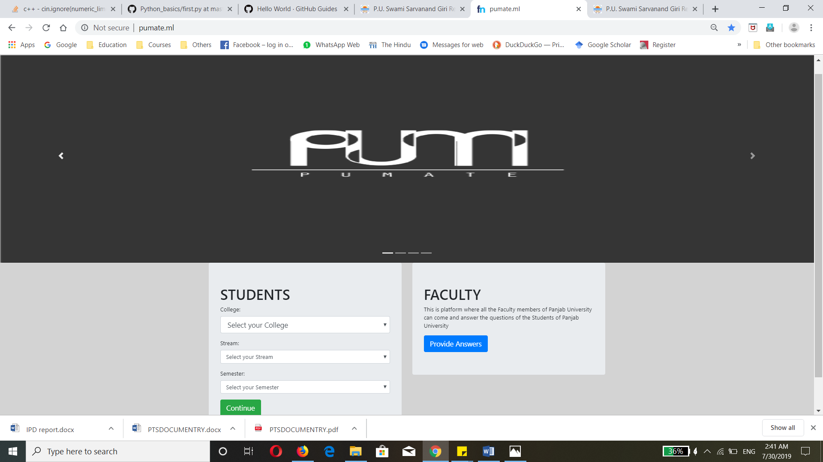

HTML:-

<!DOCTYPE html>

<html lang="en">

<head>

<meta charset="utf-8">

<title>

PUMATE

</title>

<p style="width:100%; background-color: rgba(0,0,0,0.7)"><link rel="icon" type="image/png" href="./img/logo2.png" sizes="60x60"></p>

<link rel="stylesheet" href="css/stylehome.css">

<link rel="stylesheet" href="https://stackpath.bootstrapcdn.com/bootstrap/4.3.1/css/bootstrap.min.css" integrity="sha384-ggOyR0iXCbMQv3Xipma34MD+dH/1fQ784/j6cY/iJTQUOhcWr7x9JvoRxT2MZw1T" crossorigin="anonymous">

</head>

<body>

<!-- <div class="brand" style="text-align: center;">

<img src="./img/pumate.png" style="width: 100%; height:0px;" alt="PUMATE">

</div> -->

<section>

<div id="carouselExampleIndicators" class="carousel slide" data-ride="carousel">

<ol class="carousel-indicators">

<li data-target="#carouselExampleIndicators" data-slide-to="0" class="active"></li>

<li data-target="#carouselExampleIndicators" data-slide-to="1"></li>

<li data-target="#carouselExampleIndicators" data-slide-to="2"></li>

<li data-target="#carouselExampleIndicators" data-slide-to="3"></li>

</ol>

<div class="carousel-inner">

<div class="carousel-item active">

<img class="d-block w-100" src="./img/pumate.png" style="width: 100%; height: 600px;" alt="Our Company">

</div>

<div class="carousel-item">

<img class="d-block w-100" style="width: 100%; height: 600px;" src="./img/academicHelp.png"

alt="Academic support">

</div>

<div class="carousel-item">

<img src="./img/Chatting.jpg" style="width: 100%; height: 600px;" alt="Technology-Chat">

<div class="carousel-caption d-none d-md-block">

<!-- <h5>Heading</h5>

<p>It is a paragraph or briefing</p> -->

</div>

</div>

<div class="carousel-item">

<img class="d-block w-100" style="width: 100%; height: 600px;" src="./img/donate.png" alt="Donate for College">

</div>

[JAVASCRIPT:-](javascript:-)

function gotoPage(oForm) {

var college = oForm.elements["pumateCollegeSelect"].options.selectedIndex;

var stream = oForm.elements["pumateStreamSelect"].options.selectedIndex;

var semester = oForm.elements["pumateSemesterSelect"].options.selectedIndex;

if (college === 1 && stream === 1 && semester === 1) {

window.location = "./html/cse/cse_sem1/cse_sem1.html";

return false;

}

if(college===1 && stream===1 && semester===2) {

window.location = "./html/cse/cse_sem2/cse_sem2.html";

return false;

}

if (college === 1 && stream === 1 && semester === 3) {

window.location = "./html/cse/cse_sem3/cse_sem3.html";

return false;

}

if (college === 1 && stream === 1 && semester === 4) {

window.location = "./html/cse/cse_sem4/cse_sem4.html";

return false;

}

if (college === 1 && stream === 1 && semester === 5) {

window.location = "./html/cse/cse_sem5/cse_sem5.html";

return false;

}

if (college === 1 && stream === 1 && semester === 6) {

window.location = "./html/cse/cse_sem6/cse_sem6.html";

return false;

}

if (college === 1 && stream === 1 && semester === 7) {

window.location = "./html/cse/cse_sem7/cse_sem7.html";

return false;

}

if (college === 1 && stream === 1 && semester === 8) {

window.location = "./html/cse/cse_sem8/cse_sem8.html";

return false;

} else {

alert('This Selection is not Available!');

}

}

function gotoPageSelect(select) {

if(select.selectedIndex !== 1) {

alert('Sorry! This Feature is in Development. It will be Coming Soon!!');

}

}

**Inner Home Page**

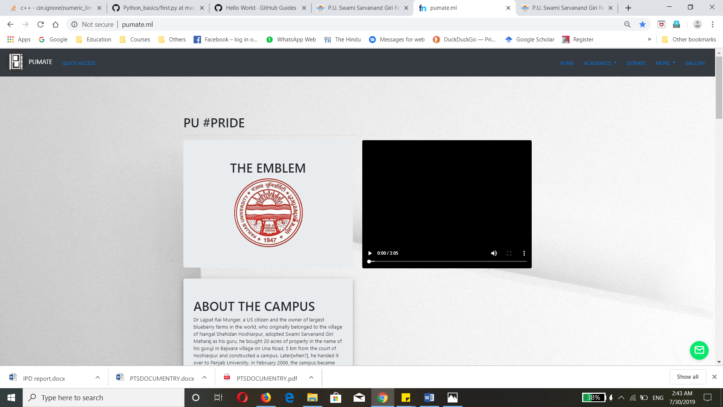

**Upcoming Events**

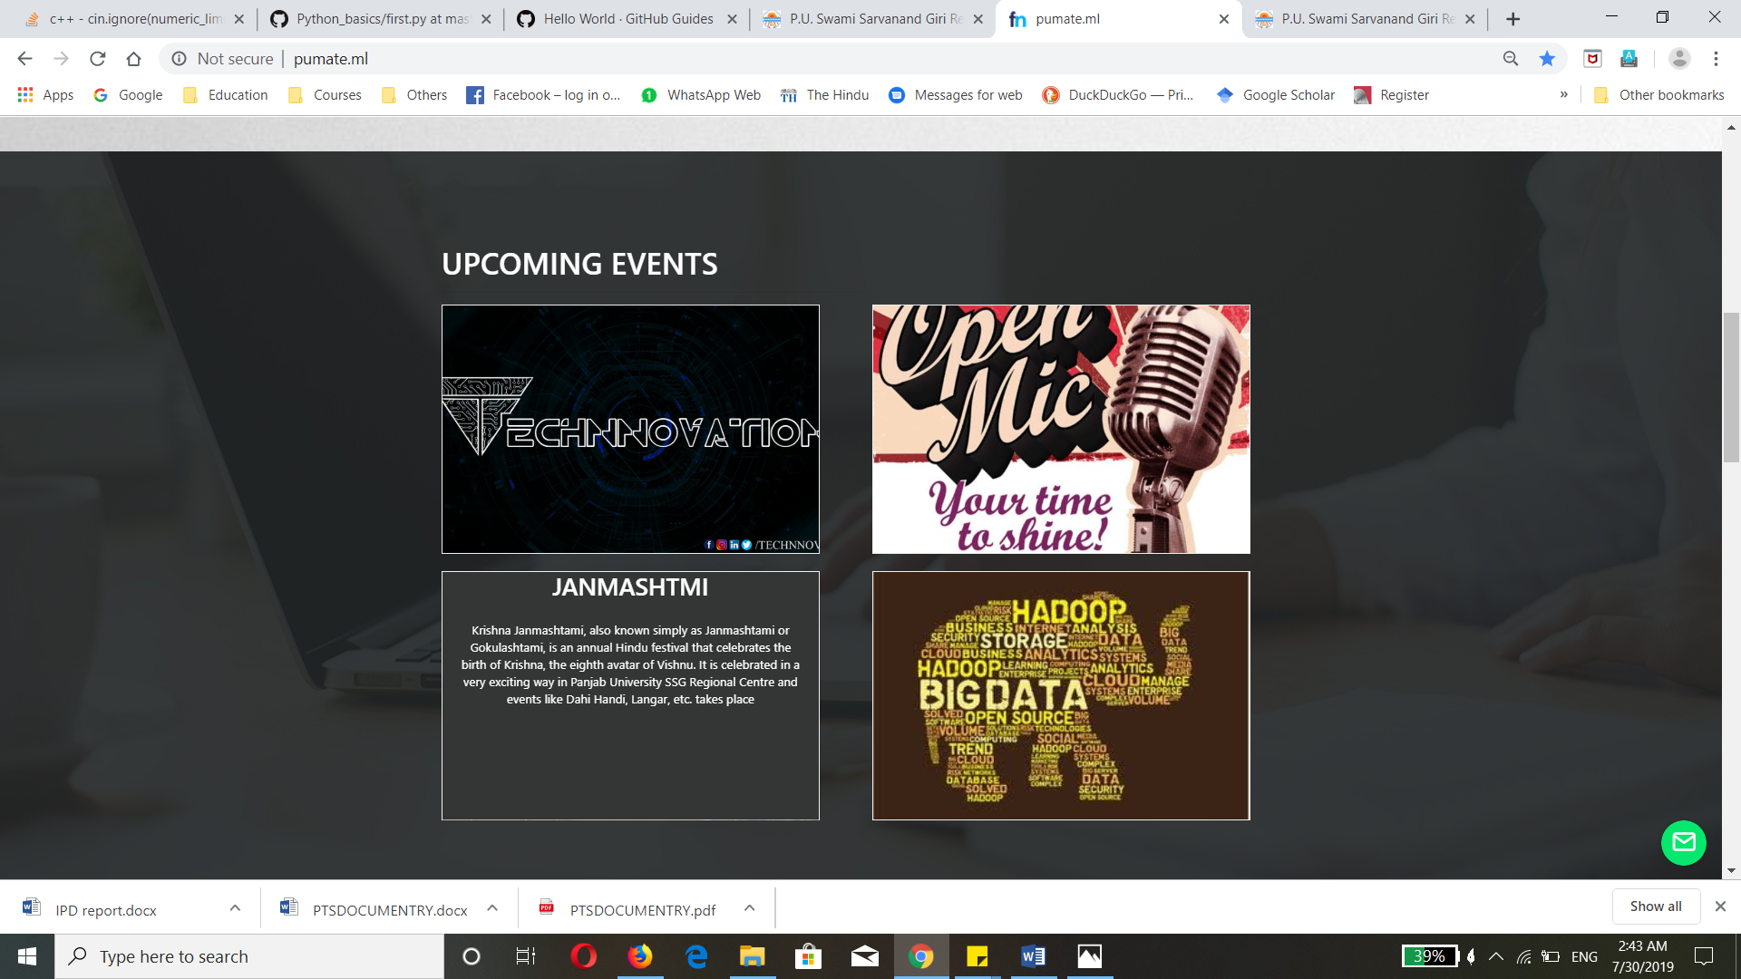

**Older Events**

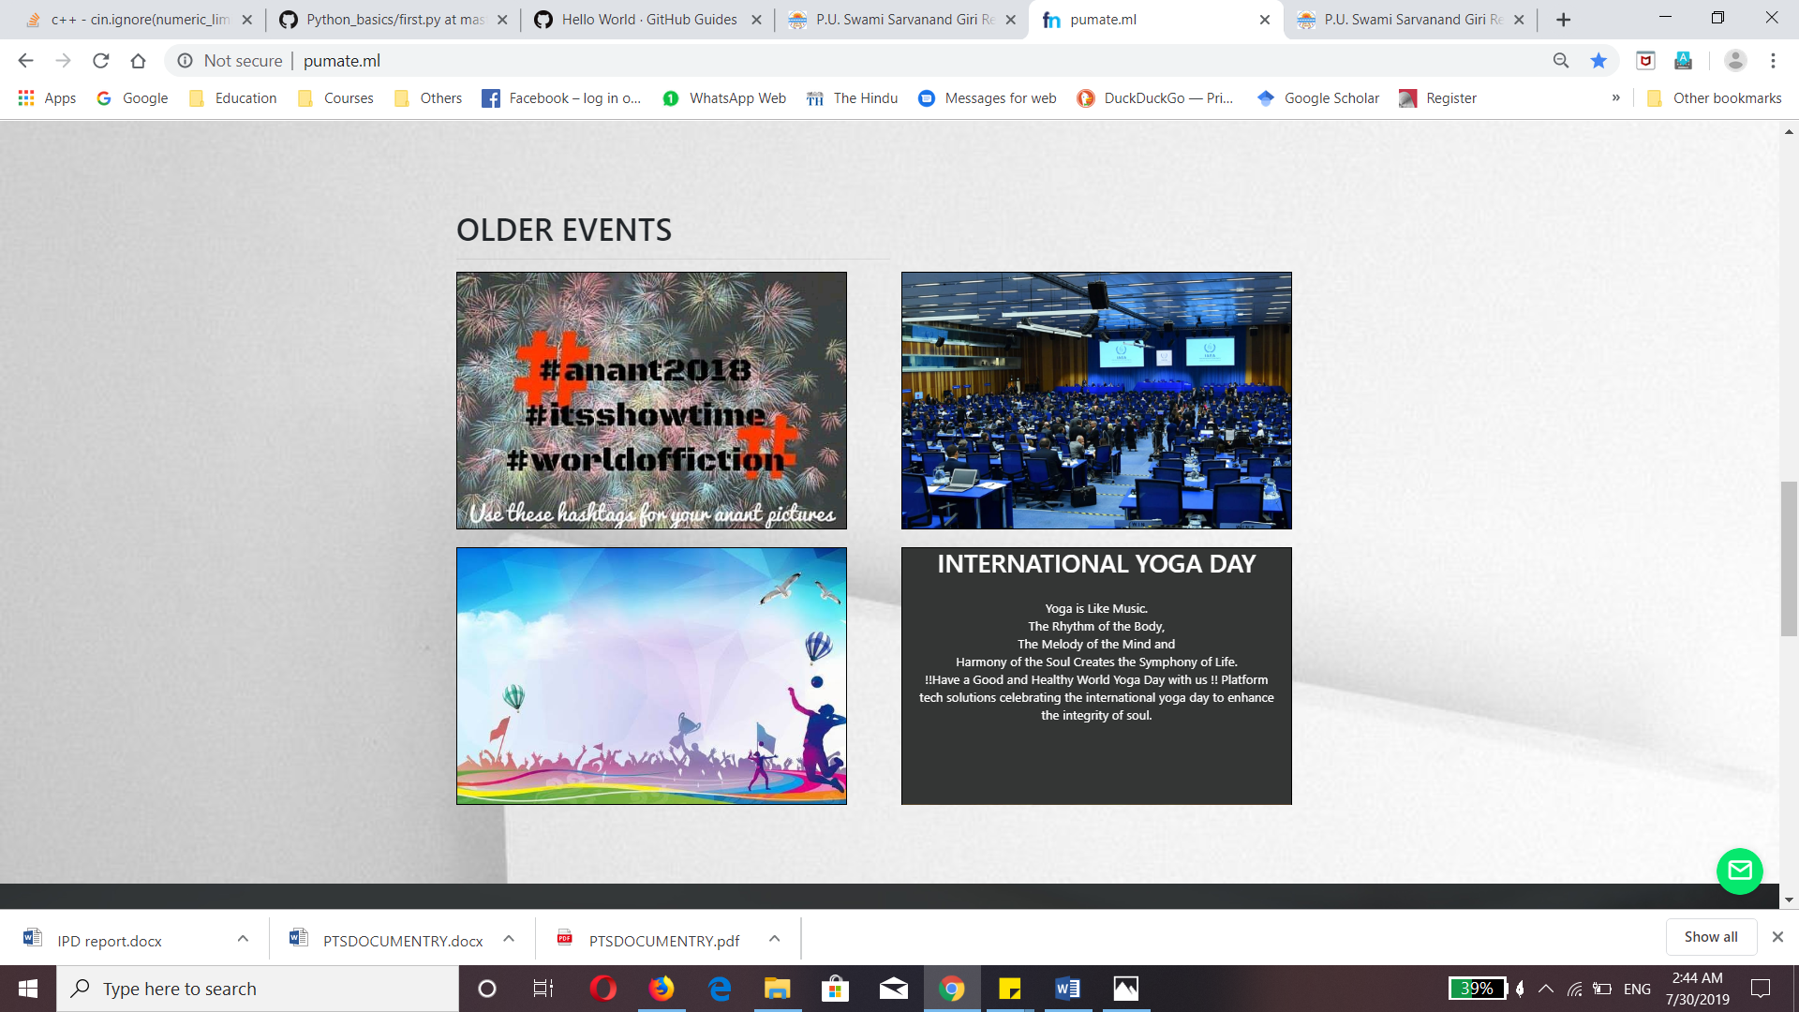

HTML:-

<!--body starts-->

<section class="pu_pride">

<div class="container">

<br>

<h1>PU #PRIDE</h1>

<hr align="left" width="50%">

<div class="row">

<div class="col-lg-6 col-md-6 col-sm-6">

<div class="jumbotron pu_emblem">

<h1 style="text-align:center">THE EMBLEM</h1>

<img src="./../../../img/pu_emblem.jpg" alt="PU EMBLEM">

</div>

<!--jumbo ends-->

</div>

<!--first grid ends-->

<div class="col-lg-6 col-md-6 col-sm-6">

<div class="jumbotron pu_anthem">

<h1>THE ANTHEM</h1>

<video controls>

<source src="./../../../video/pu_anthem.mp4" type="video/mp4">

</video>

</div>

<!--jumbo ends-->

</div>

<!--second gird ends-->

<!--first row ends-->

<div class="col-lg-6 col-sm-12 col-md-6">

<div class="jumbotron pu_event">

<h1>ABOUT THE CAMPUS</h1>

<p>Dr Lajpat Rai Munger, a US citizen and the owner of largest blueberry farms in the world, who

originally belonged to the village of Nangal Shahidan Hoshiarpur, adopted Swami Sarvanand

Giri Maharaj as his guru, he bought 20 acres of property in the name of his guruji in

Bajwara village on Una Road, 5 km from the court of Hoshiarpur and constructed a campus.

Later[when?], he handed it over to Panjab University. In February 2006, the campus became

the Regional Centre of Panjab University.</p>

</div>

<!--jumbo ends-->

</div>

<!--first grid ends-->

</div>

<!--second row ends-->

</div>

<!--this section container ends-->

</section>

<!--pu_pride section ends-->

<section class="upcoming_events">

<br>

<div class="container">

<h1 style="color:#fff;">UPCOMING EVENTS</h1>

<hr align="left" width="50%">

<div class="row">

<div class="col-lg-6 col-md-6 col-sm-12">

<div class="flip-box">

<div class="flip-box-inner">

<div class="flip-box-front">

<img src="./../../../img/technnovation.jpg" alter="Technnovation">

</div>

<div class="flip-box-back">

<h2>TECHNNOVATION</h2>

<div class="content">

<p>The distance between your dream and your accomplishments is your mindset.<br>The students of Panjab University SSG Regional Centre to promote

a conglomeration of innovative thoughts and budding ideas have taken the innitiative to conduct a liberated technical fest for the first time.

we aim at providing a platform, where students will learn and grow, where thoughts will have no boundries and nobody will be relucant to ask.

A platform where we will all learn and rise together.</p>

</div>

</div>

</div>

CSS:-

/*styling sections*/

/*#####################VIDEO#################*/

.pu_anthem {

position: relative;

overflow: hidden;

height: 25.5rem;

}

.pu_anthem video {

position: absolute;

z-index: 1;

/* top: 0; */

left: 0;

bottom: 0;

width: 100%;

height: 100%;

/* object-fit is not supported on IE */

object-fit: cover;

opacity: 1;

}

.pu_anthem h1 {

z-index: 2;

position: relative;

text-align: center;

color: rgba(0, 0, 0, 0.1);

}

.pu_anthem h1:hover {

box-shadow: 0 4px 8px 0 rgba(0, 0, 0, 0.2), 0 6px 20px 0 rgba(0, 0, 0, 0.19);

color: rgba(0, 0, 0, 0.6);

background-color: rgba(255, 255, 255, 0.3);

}

.pu_pride,

.older_events,

.image_gallery {

background: url(./../img/white_theme.jpg) center center no-repeat;

background-size: cover;

background-attachment: fixed;

padding: 100px 100px;

}

.upcoming_events,

.pu_alumini {

background: url(./../img/black_theme.jpg) center center no-repeat;

background-size: cover;

background-attachment: fixed;

padding: 100px 100px;

}

.upcoming_events hr,

.pu_alumini hr {

color: #fff;

}

.pu_pride hr,

.older_events hr,

.image_gallery hr {

color: #000;

}

.pu_pride .jumbotron img {

margin-left: 130px;

}

/*#####################Flipping in y directio################n#*/

/* The flip box container - set the width and height to whatever you want. We have added the border property to demonstrate that the flip itself goes out of the box on hover (remove perspective if you don't want the 3D effect */

.flip-box {

background-color: transparent;

width: 500px;

height: 330px;

border: 1px solid #f1f1f1;

perspective: 1000px;

/* Remove this if you don't want the 3D effect */

}

/* This container is needed to position the front and back side */

.flip-box-inner {

position: relative;

width: 100%;

height: 100%;

text-align: center;

transition: transform 0.8s;

transform-style: preserve-3d;

}

/* Do an horizontal flip when you move the mouse over the flip box container */

.flip-box:hover .flip-box-inner {

transform: rotateY(180deg);

}

**Question Paper & Syllabus**

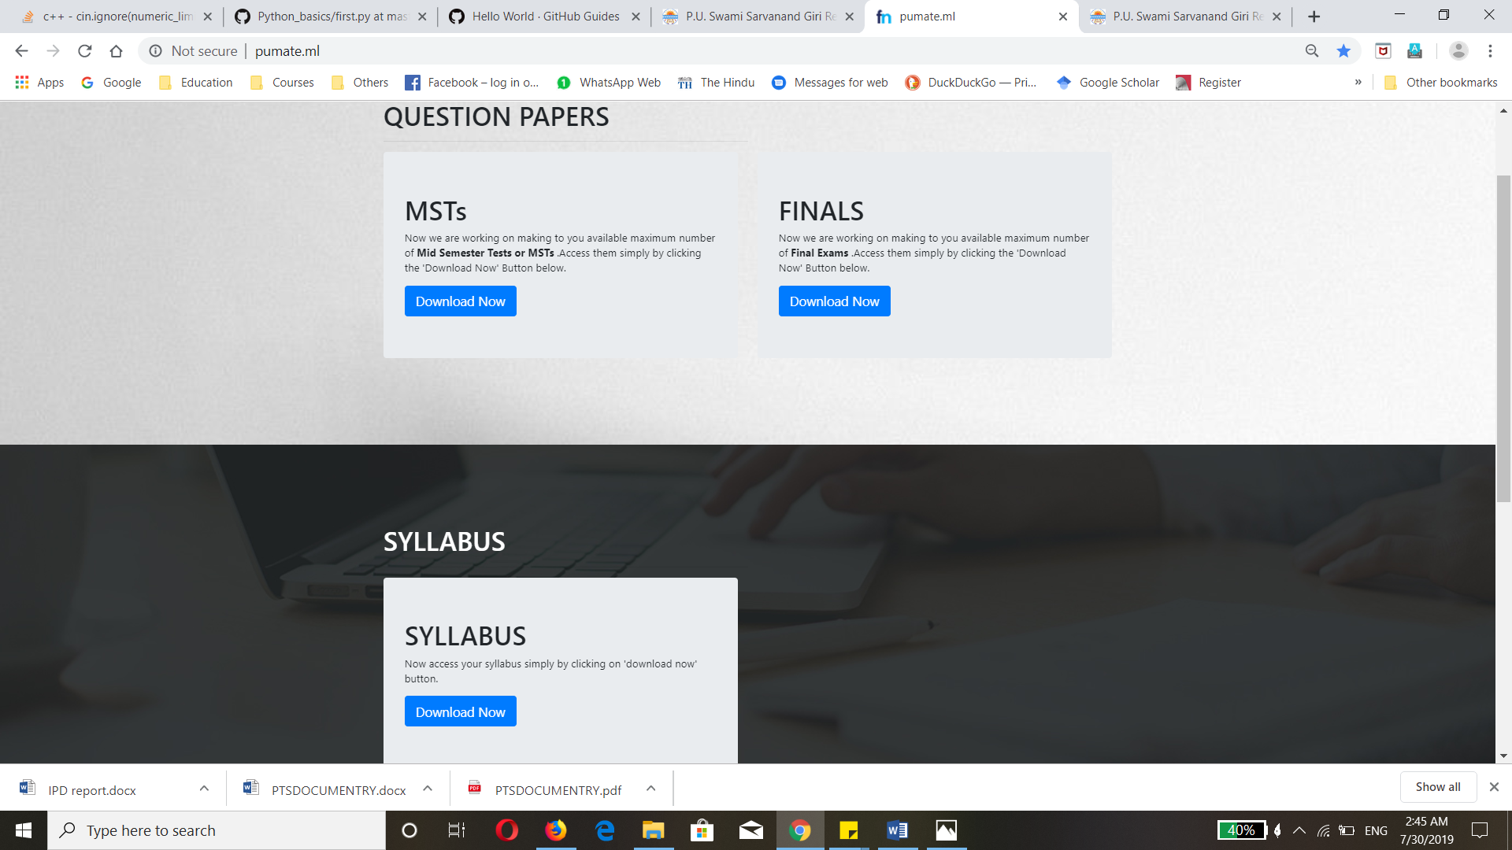

HTML:-

<!--Question Papers Starts-->

<section id="pu_ques_papers">

<br>

<div class="container">

<h1>QUESTION PAPERS</h1>

<hr align="left" width="50%">

<div class="row cse_sem1" id="question_papers">

<div class="col-lg-6 col-md-6">

<div class="jumbotron majors">

<h1>MSTs</h1>

<p>Now we are working on making to you available maximum number of <b>Mid Semester Tests or MSTs</b> .Access them simply by clicking the 'Download Now' Button below.</p>

<form action="./../../../pdfs/chemistry-by-jain-and-jain.pdf" method="get" target="_blank">

<button type="submit" class="btn btn-primary btn-lg" download role="button">Download Now</button>

</form>

</div><!--major jumbotron ends-->

</div><!--1st grid ends-->

<div class="col-lg-6 col-md-6">

<div class="jumbotron minors">

<h1>FINALS</h1>

<p>Now we are working on making to you available maximum number of <b>Final Exams</b> .Access

them simply by clicking the 'Download Now' Button below.</p>

<form action="./../../../pdfs/chemistry-by-jain-and-jain.pdf" method="get" target="_blank">

<button type="submit" class="btn btn-primary btn-lg" download role="button">Download Now</button>

</form>

</div><!--minors jumbotron ends-->

</div><!--2nd grid ends-->

</div><!--row ends-->

</div> <!--container of question paper ends-->

</section><!--Question Paper section ends here-->

<section id="pu_syllabus">

<div class="container">

<br>

<h1 style="color: #fff;">SYLLABUS</h1>

<hr align="left" width="50%">

<div class="row">

<div class="col-lg-6 col-md-6 col-sm">

<div class="jumbotron syllabus">

<h1>SYLLABUS</h1>

<p>Now access your syllabus simply by clicking on 'download now' button.</p>

<form action="./../../../pdfs/chemistry-by-jain-and-jain.pdf" method="get" target="_blank">

<button type="submit" class="btn btn-primary btn-lg" download role="button">Download Now</button>

</form>

</div><!--syllabus jumbotron ends-->

</div><!--first grid ends-->

</div><!--row ends-->

</div><!--container of syllabus ends-->

</section><!--Syllabus Section ends here-->

<section id="pu_workshops">

<div class="container">

<br>

<h1>WORKSHOPS</h1>

<hr align="left" width="50%">

<div class="row">

<div class="col-lg-6 col-md-6 col-sm">

<div class="jumbotron workshops">

<h1>WORKSHOPS</h1>

<p>Now access all your workshop files simply by clicking on 'Download now' button.</p>

<form action="./../../../pdfs/chemistry-by-jain-and-jain.pdf" method="get" target="_blank">

<button type="submit" class="btn btn-primary btn-lg" download role="button">Download Now</button>

</form>

CSS:-

#pu_ques_papers,

#pu_workshops {

background: url(./../../../img/white_theme.jpg) center center no-repeat;

background-attachment: fixed;

background-size: cover;

padding: 100px 100px;

}

#pu_syllabus {

background: url(./../../../img/black_theme.jpg) center center no-repeat;

background-attachment: fixed;

background-size: cover;

padding: 100px 100px;

}

**Commities**

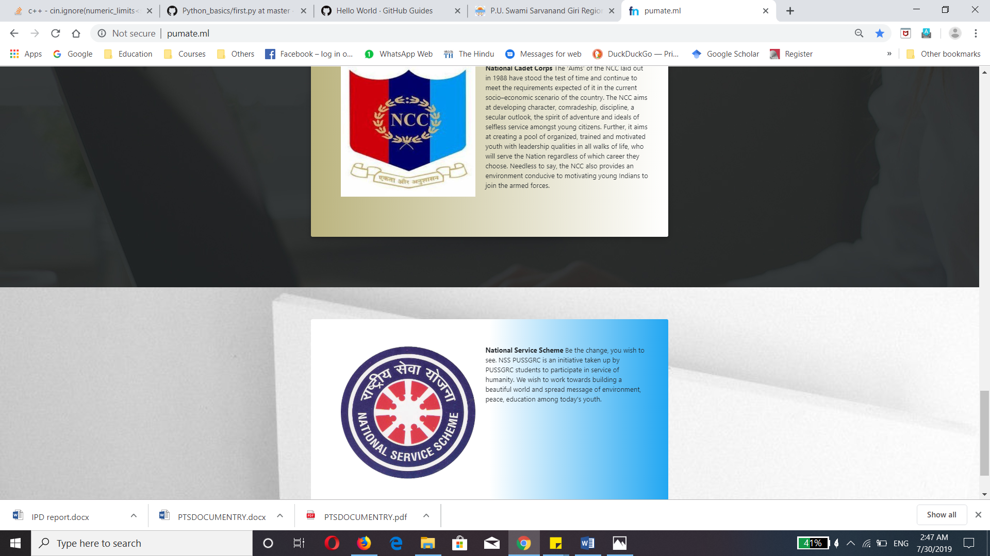

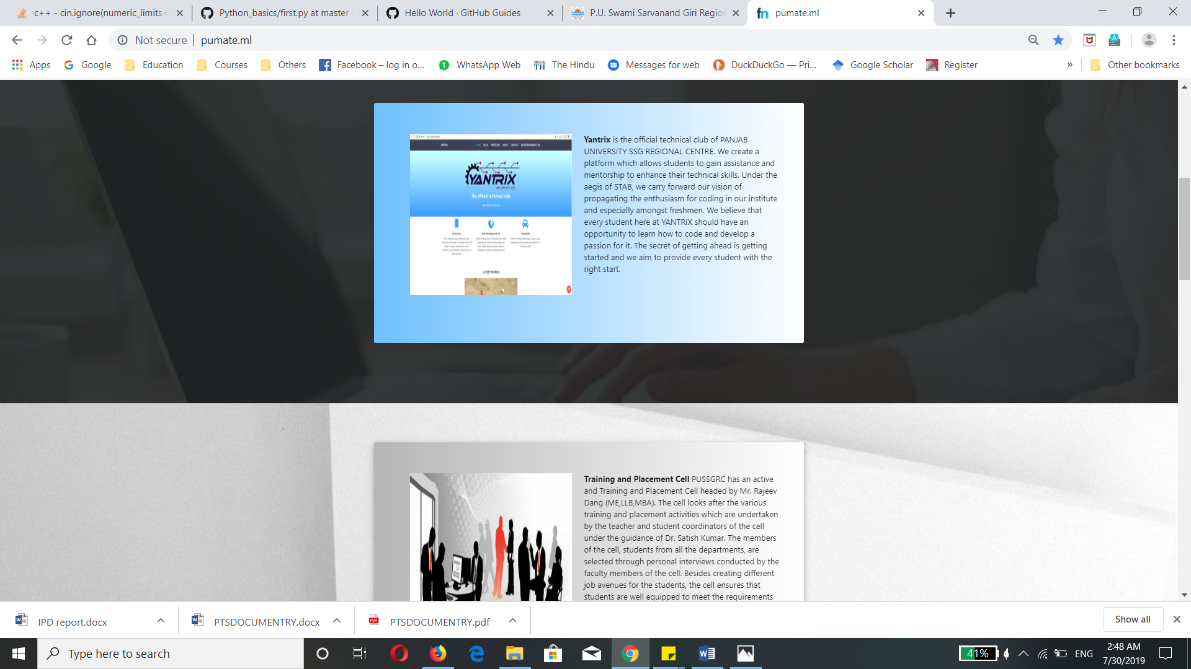

HTML:-

<section class="cards">

<section class="shor">

<div class="container">

<div class="jumbotron">

<div class="clearfix">

<img src="./../../../img/shor_p1.jpeg" class="float-left">

<p><strong>SHOR</strong> is the newly born and official theatre group of PUSSGRC Hoshiarpur,

formed as a result of the collaboration between previous two drama communities. As the name

suggests, we aim to make an impact on the society by raising our voice on socially relevant,

pressing and urgent topics. Our scripts never fail to entice the audience with uniqueness in the

topic, it's depiction and it's deep rooted connection within our society. We offer candidates,

with a flair of acting, expressive emotions and voice projection a plethora of theatre types to

choose from, be it street plays, mime, mono-acting, musicals or stage theatre. SHOR, as a team

is a group of completely dedicated, committed and sincere people who are fiercely passionate

about acting and theatre, we aim to maintain the legacy, very carefully formed by our respected

seniors and mentors. As a relatively new team, we have a long way to go, but with the right

amount of dedication, sincerity and zeal, we can touch skies unheard of. Because ultimately, all

the world's a theatre and we plan on a standing ovation.</p>

</div>

</div>

<br>

</div><!--container ends-->

</section><!--shor section ends-->

<section class="yantrix">

<div class="container">

<div class="jumbotron">

<div class="clearfix">

<img src="./../../../img/Yantrix.png" class="float-left">

<p><strong>Yantrix</strong> is the official technical club of PANJAB UNIVERSITY SSG REGIONAL

CENTRE.

We create a platform which allows students to gain assistance and mentorship to enhance their

technical skills. Under the aegis of STAB, we carry forward our vision of propagating the

enthusiasm for coding in our institute and especially amongst freshmen.

We believe that every student here at YANTRIX should have an opportunity to learn how to code

and develop a passion for it. The secret of getting ahead is getting started and we aim to

provide every student with the right start.</p>

</div>

</div>

<br>

</div><!--container ends-->

</section><!--yantrix section ends-->

<section class="tpc">

<div class="container">

<div class="jumbotron">

<div class="clearfix">

<img src="./../../../img/tpc.jpg" class="float-left">

<p><strong>Training and Placement Cell</strong> PUSSGRC has an active and Training and Placement

Cell headed by Mr. Rajeev Dang (ME,LLB,MBA). The cell looks after the various training and

placement activities which are undertaken by the teacher and student coordinators of the cell

under the guidance of Dr. Satish Kumar. The members of the cell, students from all the

departments, are selected through personal interviews conducted by the faculty members of the

cell. Besides creating different job avenues for the students, the cell ensures that students

are well equipped to meet the requirements of the industry. The students of the institute have

been placed in reputed firms like Birlasoft, Infosys, Accenture, Igate Patni, Quark, Dell,

Infogain, Nucleus Software, Wipro, Ambuja Cement, IBM, Mahindra & Mahindra, Sml Isuzu & the

Indian Army. </p>

</div>

</div>

<br>

</div><!--container ends-->

</section><!--tpc ends-->

<section class="dcult">

<div class="container">

<div class="jumbotron">

<div class="clearfix">

<img src="./../../../img/dcult.jpeg" class="float-left">

<p><strong>D Cult</strong> was formed in the year 2009 by few of the college buddies of

PANJAB UNIVERSITY SWAMI SARVANAND GIRI REGIONAL CENTRE,HOSHIARPUR.

*CSS:-*

/*styling sections*/

.shor,

.tpc,

.literati,

.nss {

background: url(./../../../img/white_theme.jpg) center center no-repeat;

background-size: cover;

background-attachment: fixed;

padding: 100px 100px;

}

.yantrix ,

.dcult,

.ncc {

background: url(./../../../img/black_theme.jpg) center center no-repeat;

background-size: cover;

background-attachment: fixed;

padding: 100px 100px;

}

**Enterprenours**

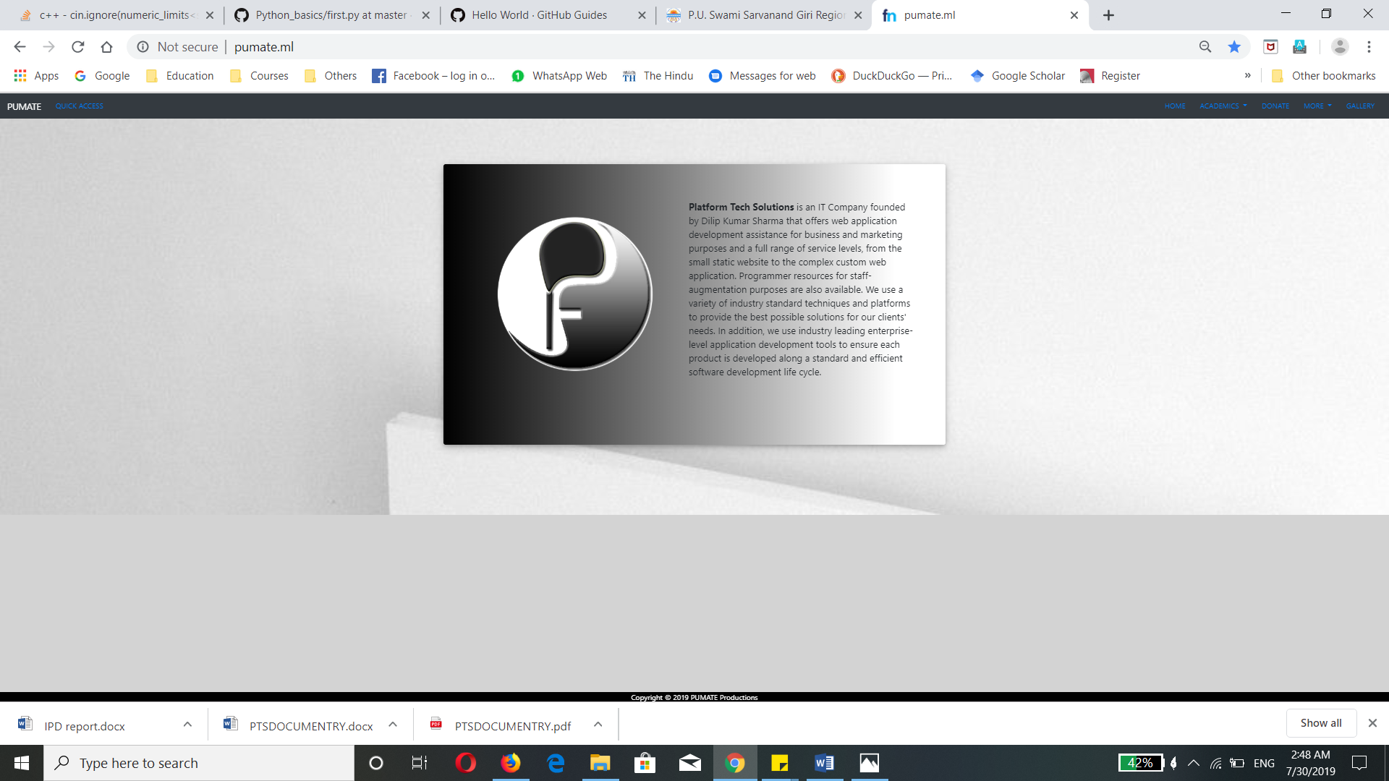

HTML & CSS:-

<section class="cards">

<div class="container">

<div class="jumbotron">

<div class="clearfix">

<img src="./../../../img/platform.png" class="float-left">

<p><strong>Platform Tech Solutions</strong> is an IT Company founded by Dilip Kumar Sharma that

offers web application development assistance for business and marketing purposes and a full

range of service levels, from the small static website to the complex custom web application.

Programmer resources for staff-augmentation purposes are also available. We use a variety of

industry standard techniques and platforms to provide the best possible solutions for our

clients' needs. In addition, we use industry leading enterprise-level application development

tools to ensure each product is developed along a standard and efficient software development

life cycle.</p>

</div>

</div>

</div>

<br>

</div><!--container ends-->

</section>

<!--body ends-->

<!--Footer-->

<footer>

Copyright &copy; 2019 PUMATE Productions

</footer>

<!--Footer Ends-->

<style>

.cards {

background: url(./../../../img/white_theme.jpg) center center no-repeat;

background-size: cover;

background-attachment: fixed;

padding: 100px 100px;

}

</style>

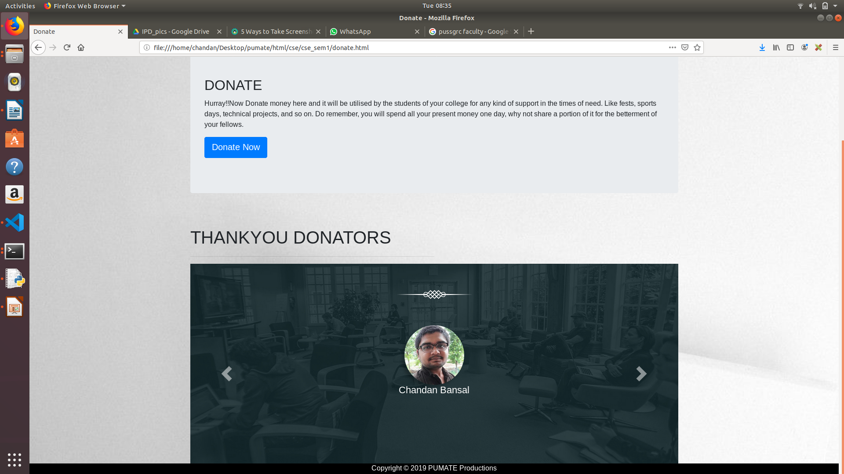

CODE:-

<section id="donate">

<br><br><br><br><br>

<div class="container">

<div class="row">

<div class="col-lg-12 col-md-12 col-sm-12">

<div class="jumbotron">

<h2>DONATE</h2>

<p>Hurray!!Now Donate money here and it will be utilised by the students of your college for

any kind of support in the times of need.

Like fests, sports days, technical projects, and so on. Do remember, you will spend all

your present money one day, why not share a portion of it for the betterment of your

fellows.

</p>

<form action="https://instamojo.com/@pumate" method="get" target="_blank">

<button type="submit" class="btn btn-primary btn-lg" role="button">Donate Now</button>

</form>

</div>

</div>

</div>

<br><br>

<h1>THANKYOU DONATORS</h1>

<hr align="left" width="50%">

<section class="testimonial text-center">

<div class="heading white-heading">

</div>

<div id="testimonial4"

class="carousel slide testimonial4_indicators testimonial4_cont rol_button thumb_scroll_x swipe_x"

data-ride="carousel" data-pause="hover" data-interval="5000" data-duration="2000">

<div class="carousel-inner" role="listbox">

<div class="carousel-item active">

<div class="testimonial4_slide">

<img src="./../../../img/donor1.jpg"

class="img-circle img-responsive" />

<h4>Gaurav Anand</h4>

</div>

</div>

<div class="carousel-item">

<div class="testimonial4_slide">

<img src="./../../../img/donor2.jpg"

class="img-circle img-responsive" />

<h4>Akshay Krity</h4>

</div>

</div>

<div class="carousel-item">

<div class="testimonial4_slide">

<img src="./../../../img/donor3.jpg"

class="img-circle img-responsive" />

<h4>Chandan Bansal</h4>

</div>

</div>

</div>

<a class="carousel-control-prev" href="#testimonial4" data-slide="prev">

<span class="carousel-control-prev-icon"></span>

</a>

<a class="carousel-control-next" href="#testimonial4" data-slide="next">

<span class="carousel-control-next-icon"></span>

</a>

</div>

<br><br>

</section>

<style>

#donate {

background: url(./../../../img/white_theme.jpg) center center no-repeat;

background-size: cover;

background-attachment: fixed;

}

</style>

**Quick Access**

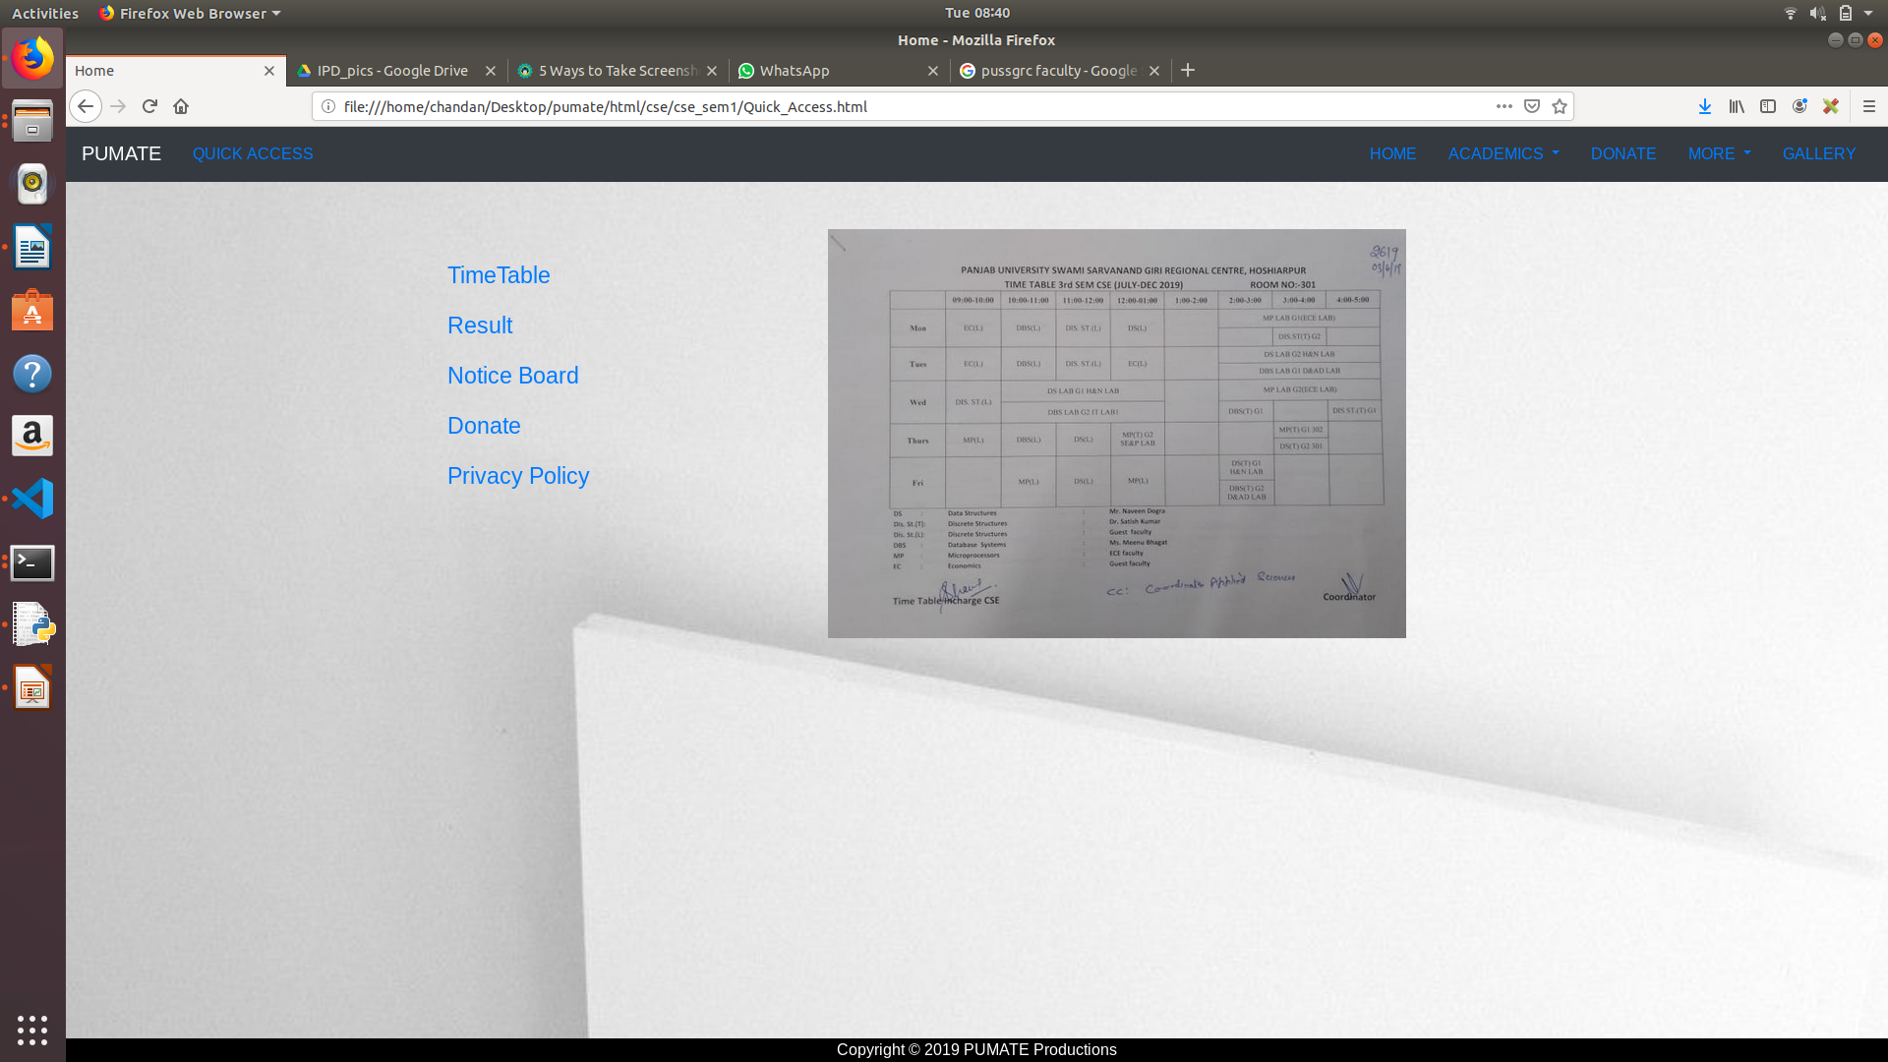

HTML:-

<!-- Linking starts of vertical nav-->

<section class="quick_access">

<div class="container mtb">

<div class="row">

<div class="col-lg-3">

<div class="gap"><br><br><br></div>

<ul style="list-style: none;" class="nav flex-column" id="myTab1">

<li class="nav-item"><a href="#PU_Timetable NIa" class="nav-link active size"

onclick="TimetableFunctionality()">TimeTable</a></li>

<li class="nav-item"><a href="#PU_Result NIa" class="nav-link size"

onclick="ResultFunctionality()">Result</a></li>

<li class="nav-item"><a href="#PU_Notice_Board NIa" class="nav-link size"

onclick="NoticeFunctionality()">Notice Board</a></li>

<li class="nav-item"><a href="#PU_Donate NIa" id="mainTarget" class="nav-link size"

onclick="DonateFunctionality()">Donate</a></li>

<li class="nav-item"><a href="#PUMATE_Policy NIa" class="nav-link size"

onclick="PUMATEPrivacyFunctionality()">Privacy Policy</a></li>

</ul>

<style>

.NIa:active {

background-color: #a6a5a4;

border-radius: 5px;

padding: 5px inherit 5px 5px;

border: 1px solid #a6a5a4;

color: #fd3300;

}

.size {

font-size: 145%;

}

.size:hover {

border: 1px solid #fd3300;

border-radius: 5px;

box-sizing: border-box;

border-width: auto;

}

h2 {

color: #760972;

}

</style>

</div>

<div class="col-lg-9">

<div class="visibility" id="PU_Timetable" style="display:block;">

<div class="gap"><br><br></div>

<div class="container" style="width: 75%;">

<div class="jumbotron PU_Timetable">

<img src="./../../../img/timetable_csesem3.jpeg" alt="timtable">

</div>

</div>

</div>

<div class="visibility active" id="PU_Result" style="display:none;">

<div class="gap"><br><br></div>

<div class="container" style="width: 75%;">

<div class="jumbotron">

<h2>RESULT</h2>

<p>By clicking on the Link given below, you will be redirected to the page where you will be shown your result.

Best of Luck, may you achieve high ranking positions in your life.

</p>

<form action="http://eakadamik.in/uiethsp/" method="get" target="_blank">

<button type="submit" class="btn btn-primary btn-lg" role="button">Get Result</button>

</form>

<!-- <button type="button" class="btn btn-primary btn-lg" role="button">Get Result</button> -->

</div>

</div>

</div>

[JAVASCRIPT:-](javascript:-)

<!--Linking ends of vertical nav-->

<script type="text/javascript">

TimetableFunctionality = () => {

var lefts = document.querySelectorAll("#PU_Result, #PU_Notice_Board, #PU_Donate, #PUMATE_Policy");

document.getElementById("PU_Timetable").style.display = "block";

var length = lefts.length;

for (var i = 0; i < length; i++) {

lefts[i].style.display = "none";

}

}

ResultFunctionality = () => {

var lefts = document.querySelectorAll("#PU_Timetable, #PU_Notice_Board, #PU_Donate, #PUMATE_Policy");

document.getElementById("PU_Result").style.display = "block";

var length = lefts.length;

for (var i = 0; i < length; i++) {

lefts[i].style.display = "none";

}

}

NoticeFunctionality = () => {

var lefts = document.querySelectorAll("#PU_Timetable, #PU_Result, #PU_Donate, #PUMATE_Policy");

document.getElementById("PU_Notice_Board").style.display = "block";

var length = lefts.length;

for (var i = 0; i < length; i++) {

lefts[i].style.display = "none";

}

}

DonateFunctionality = () => {

var lefts = document.querySelectorAll("#PU_Timetable, #PU_Result, #PU_Notice_Board, #PUMATE_Policy");

document.getElementById("PU_Donate").style.display = "block";

var length = lefts.length;

for (var i = 0; i < length; i++) {

lefts[i].style.display = "none";

}

}

PUMATEPrivacyFunctionality = () => {

var lefts = document.querySelectorAll("#PU_Timetable, #PU_Result, #PU_Notice_Board, #PU_Donate");

document.getElementById("PUMATE_Policy").style.display = "block";

var length = lefts.length;

for (var i = 0; i < length; i++) {

lefts[i].style.display = "none";

}

**Gallery**

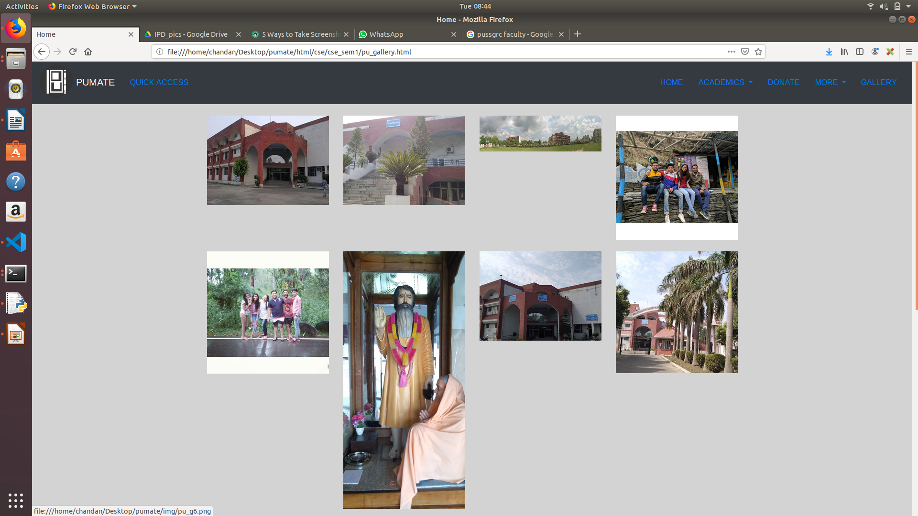

CODE:-

<div class="container">

<div class="row">

<div class="col-lg-3 col-md-3 col-sm-4">

<div class="thumbnail">

<a href="./../../../img/pu_g1.png">

<img src="./../../../img/pu_g1.png" alt="Lights" style="width:100%">

</a>

</div>

</div><!--1st grid ends-->

<div class="col-lg-3 col-md-3 col-sm-4">

<div class="thumbnail">

<a href="./../../../img/pu_g2.png">

<img src="./../../../img/pu_g2.png" alt="Lights" style="width:100%">

</a>

</div>

</div><!--1st grid ends-->

<div class="col-lg-3 col-md-3 col-sm-4">

<div class="thumbnail">

<a href="./../../../img/pu_g3.png">

<img src="./../../../img/pu_g3.png" alt="Lights" style="width:100%">

</a>

</div>

</div><!--1st grid ends-->

<div class="col-lg-3 col-md-3">

<div class="thumbnail">

<a href="./../../../img/pu_g4.png">

<img src="./../../../img/pu_g4.png" alt="Lights" style="width:100%">

</a>

</div>

</div><!--1st grid ends-->

</div><!--row ends--><br>

<div class="row">

<div class="col-lg-3 col-md-3 col-sm-4">

<div class="thumbnail">

<a href="./../../../img/pu_g5.png">

<img src="./../../../img/pu_g5.png" alt="Lights" style="width:100%">

</a>

</div>

</div><!--1st grid ends-->

<div class="col-lg-3 col-md-3 col-sm-4">

<div class="thumbnail">

<a href="./../../../img/pu_g6.png">

<img src="./../../../img/pu_g6.png" alt="Lights" style="width:100%">

</a>

</div>

</div><!--1st grid ends-->

<div class="col-lg-3 col-md-3 col-sm-4">

<div class="thumbnail">

<a href="./../../../img/pu_g7.png">

<img src="./../../../img/pu_g7.png" alt="Lights" style="width:100%">

</a>

</div>

</div><!--1st grid ends-->

<div class="col-lg-3 col-md-3">

<div class="thumbnail">

<a href="./../../../img/pu_g8.png">

<img src="./../../../img/pu_g8.png" alt="Lights" style="width:100%">

</a>

</div>

</div><!--1st grid ends-->

</div>

<!--row ends--><br>

<div class="row">

<div class="col-lg-3 col-md-3 col-sm-4">

<div class="thumbnail">

<a href="./../../../img/pu_g9.png">

<img src="./../../../img/pu_g9.png" alt="Lights" style="width:100%">

</a>

**Code for tawk API:-**

<!--Start of Tawk.to Script-->

<script type="text/javascript">

var Tawk_API = Tawk_API || {},

Tawk_LoadStart = new Date();

(function () {

var s1 = document.createElement("script"),

s0 = document.getElementsByTagName("script")[0];

s1.async = true;

s1.src = 'https://embed.tawk.to/5d3d8cd29b94cd38bbe9afc5/default';

s1.charset = 'UTF-8';

s1.setAttribute('crossorigin', '*');

s0.parentNode.insertBefore(s1, s0);

})();

</script>

<!--End of Tawk.to Script-->

**Payment Gateway Url**

https://instamojo.com/@pumate